**ANALYSIS REPORT**

**FOR**

**WHATSAPP DATA ANALYSIS SYSTEM**

**BY GROUP X**

Table of Contents

1 Introduction 3

2 Data cleaning 3

2.1 Analysis 3

3 Analysis of posts per sender 4

3.1 Analysis 4

3.2 Observations and Recommendations 4

4 Most common words by length 5

4.1 Analysis 5

4.2 Observation and recommendation 5

5 Word cloud 6

5.1 Analysis 6

5.2 Observation and Recommendations 6

6 Messages sent by time of the day per person 7

# Introduction

This analysis report comprises of all analysis on the WhatsApp data

# Data cleaning

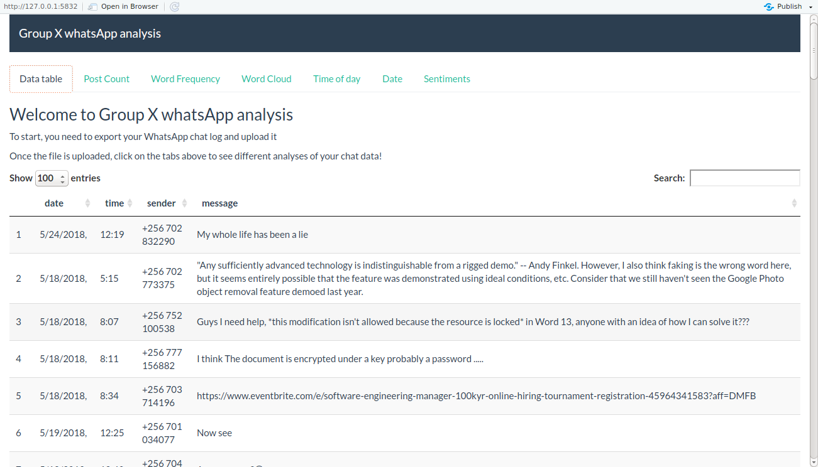

Figure 1: Data cleaning

## Analysis

Data was cleaned to successfully by getting rid of unwanted data expression such as <media omitted>.

The clean data is seperated into data, time, sender and messages.

# Analysis of posts per sender

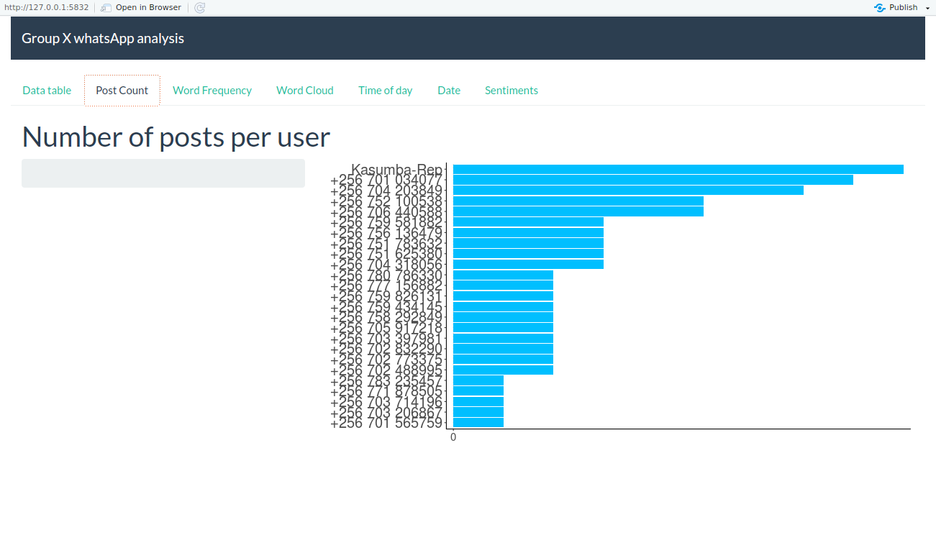

Figure 2: Number of posts per uer

## Analysis

The most number of posts were from Kasumba-rep observed by the longest bar as shown on the bar graph. The least number of post were observed from +256701565759.

## Observations and Recommendations

Kasumba-rep is the most active user in the group chat. +256701565759 is the least active user in the group chat.

# Most common words by length

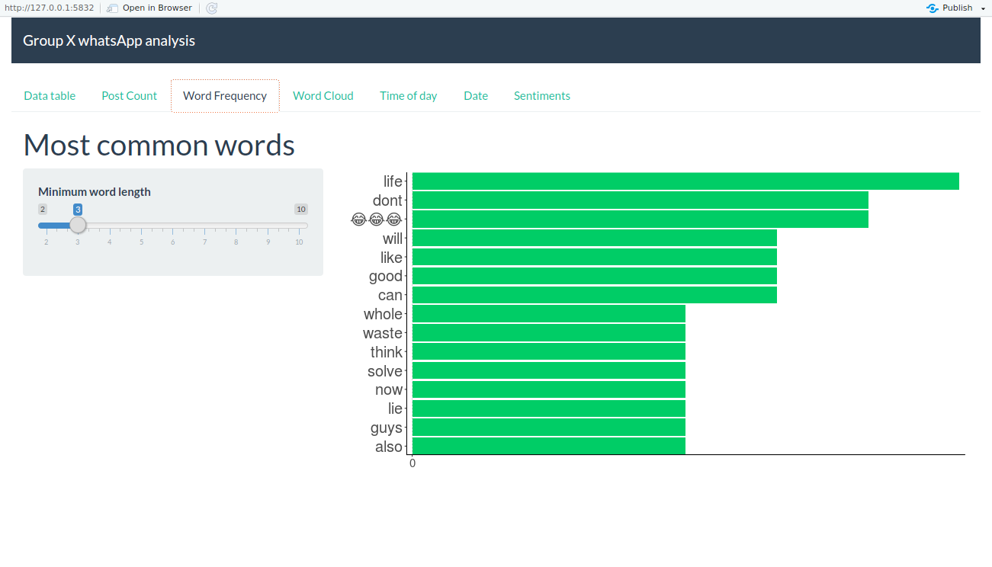

Figure 3: Most common used words

Figure 3: analysis graph of fatality versus Region.

## Analysis

## Observation and recommendation

.

# Word cloud

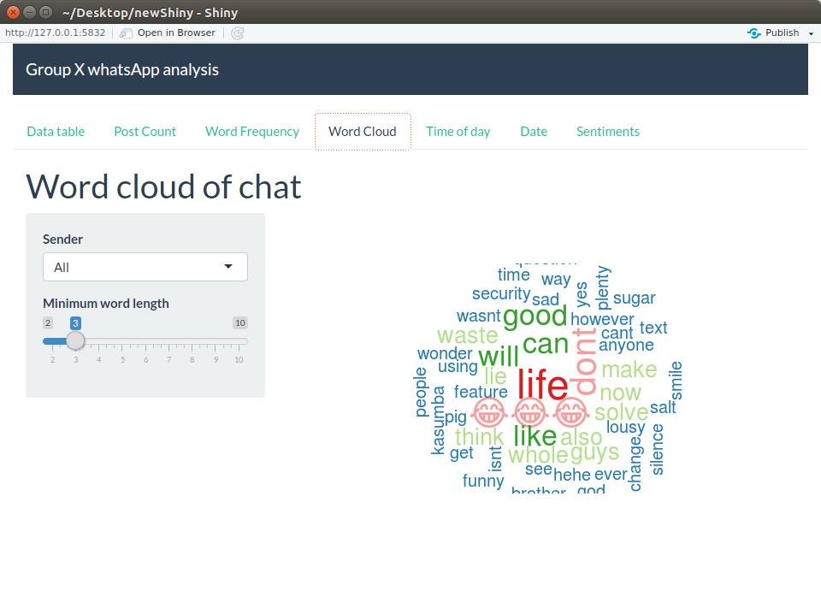

Figure 4: Word cloud

## Analysis

## Observation and Recommendations

# Messages sent by time of the day per person

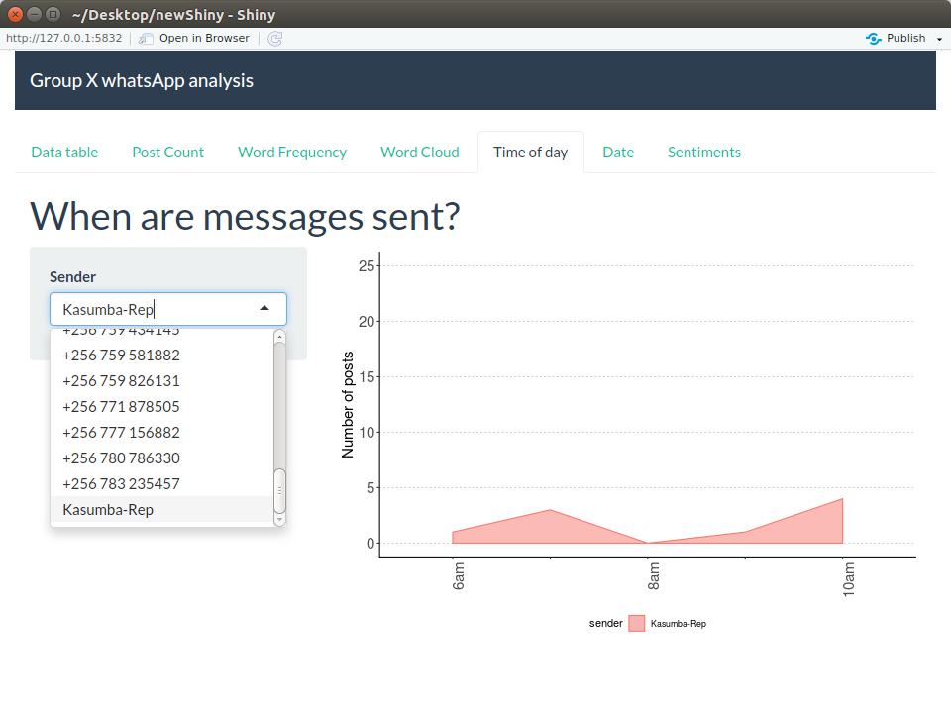

Figure 5:Messages sent by time of the day per person